Sudharshan Vishwa.M.S

b.tECH AiDS-‘B’| rrn:220171601113

Bank Complaint Analysis – Using Tableau

Data Mining assigntment-Cat1[csd2254]

**Bank Complaint Analysis of USA – Dashboard Explanation**

This Dashboard is created based on a dataset which does contains the customer’s complaint regarding banking issues such as credit card,debit card,etc.. towards various banking organizations present in the united states.

This Dataset contains various fields such as bank name,customer complaints,customer response,issue,state,zipcode etc..

(For full data set,Google drive link has been inserted along with this document)

Let us see sheet-wise explanation of the dashboard,

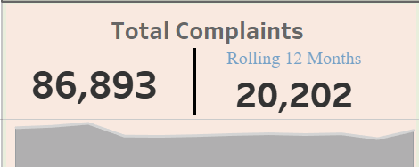

This part of the dashboard contains,

1)Total no.of complaints-[sheet-1]

2)Rolling complaints of last 12 months-[sheet-2]

3)Complaints Sparkline which is a Area Graph and line graph put together in dual axis-[sheet-3]

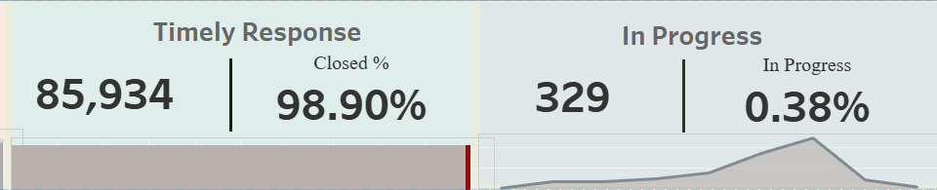

This part of the dashboard contains,

4)The amount of response given by the bank in Time-[sheet-4]

5)The percentage of solved complaints by bank-[Sheet5]

6)A Progress Graph of solved complaints-[sheet-6]

7)The amount of complaints in Progress of solving-[sheet-7]

8)The percentage of In-Progress Complaints-[sheet-8]

9)The Progress Sparkline of In-Progress Complaints-[sheet-9]

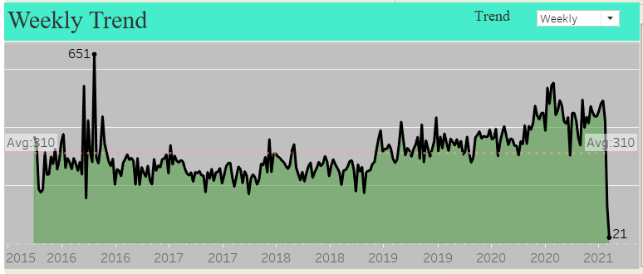 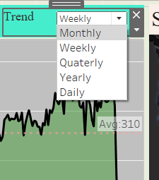

10)This is a line Graph and a Area chart put together into a dual Axis which tells us the amount of complaints alongside the year in which the trend is fluctuating. It does also contain a parameter which gives us the option of changing the weekly,monthly,quarterly,and monthly trends-[sheet-10]

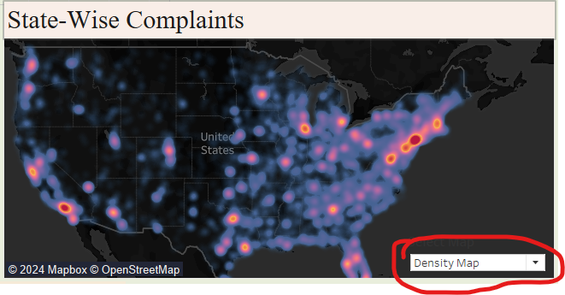

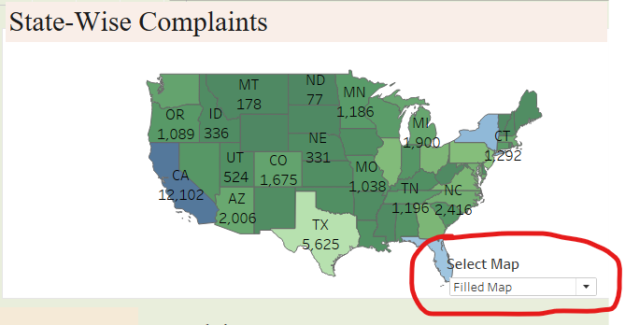

11)This a Map-Graph which tells us which part of US has the most number of complaints received along with numbers.There are two types of maps given,i.e,a density map and a filled map which can be changed using a parameter.-[sheet-11]

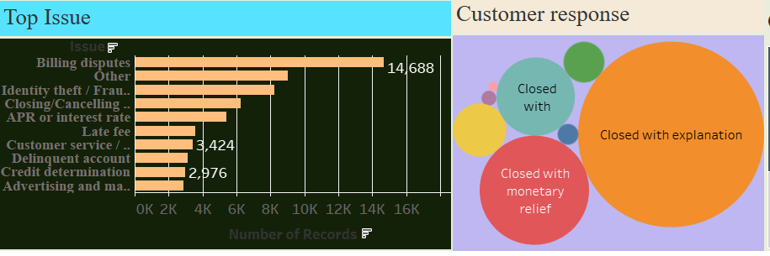

12) This is a bar type graph which gives the analysis of the issues of the customer which has be plotted alongside the number of records and data and numbers given-[sheet-12]

13)The next plot is a Closed Bubbles plot which gives us the analysis of customer response towards each company-[sheet-13]

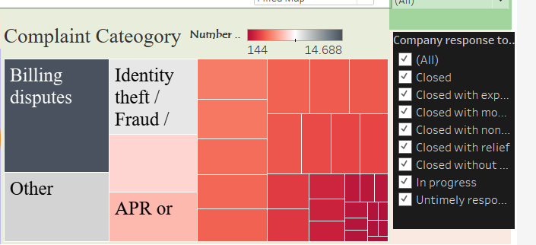

14)This contains a Tree map which does Contain the type of complaint and it’s category with the company’s number of records.

It also contains a Filter which gives the option of choosing the complaint cateogory by the user.-[sheet-14,15]

**Filters:**

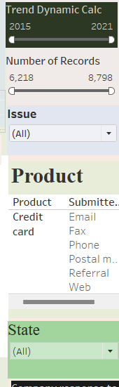

These are the filters and slicers included in the dashboard which lets us the option customizing the user’s view to the dashboard,

1)Filter for number of dynamic calculations.

2)Filter for Number of Records.

3)Filter for Type of issue of bank.

4)Slicer to select the type of Product

5)Filter to select the state in US.

Dataset-https://drive.google.com/drive/folders/1bFLIZ03GIavisLU2n9m1K8gldqEUNdNc

……………………………Thank YOU!!..............................................